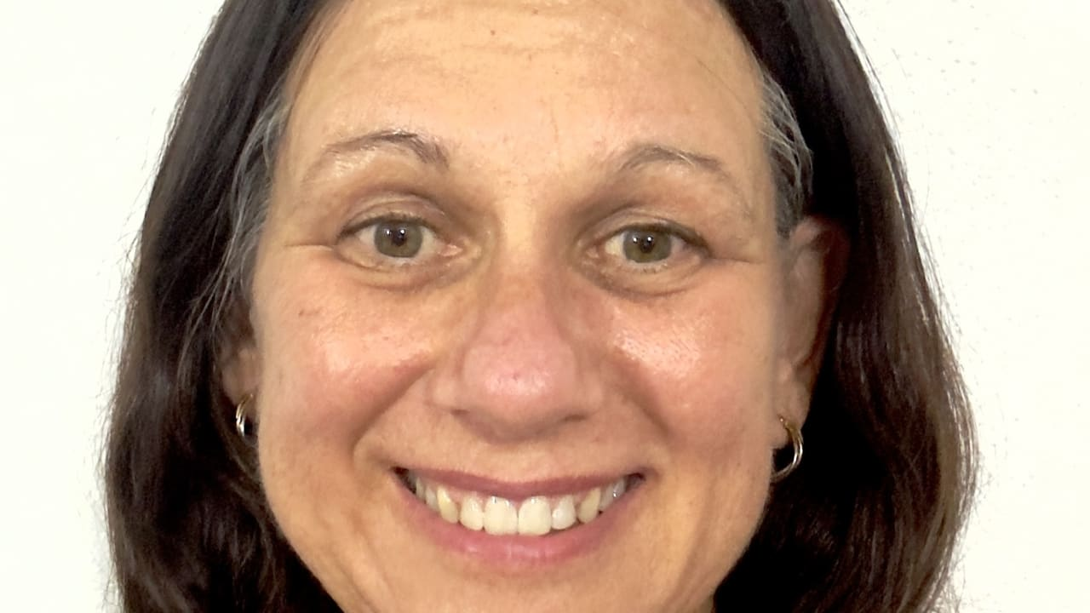

Bradaag welcomes new General Manager
Feb 16, 2024
Updated February 16, 2024
1 min read.
Tash Adams
THE Directors of Barkly Region Alcohol and Drug Abuse Advisory Group (BRADAAG) have announced the appointment of its new General Manager.
Natalie McCabe will helm the rehabilitation organisation in April.
She brings a wealth of experience within the public sector and Indigenous organisations in regional Australia.
A spokesperson said the Directors are confident Ms McCabe’s strong leadership, ability to engage with all and effective management skills will take BRADAG forward in achieving its vision and aspirations as the organisation transitions to a new integrated therapeutic model of wellbeing across the Barkly.
https://www.tdtimes.com.au/news/bradaag-welcomes-new-general-manager?amp=1

